http://localhost:8080/btl/api/dienthoai
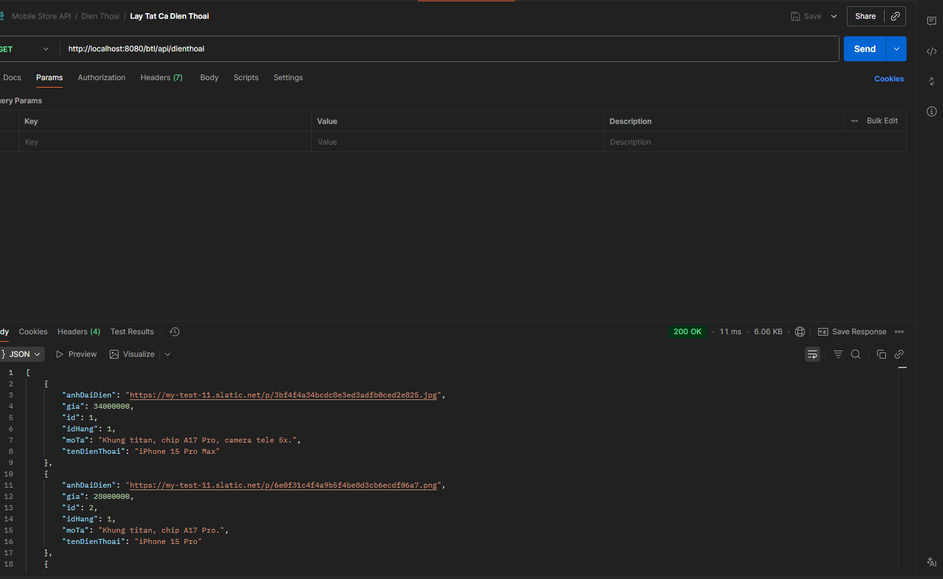

http://localhost:8080/btl/api/dienthoai/1
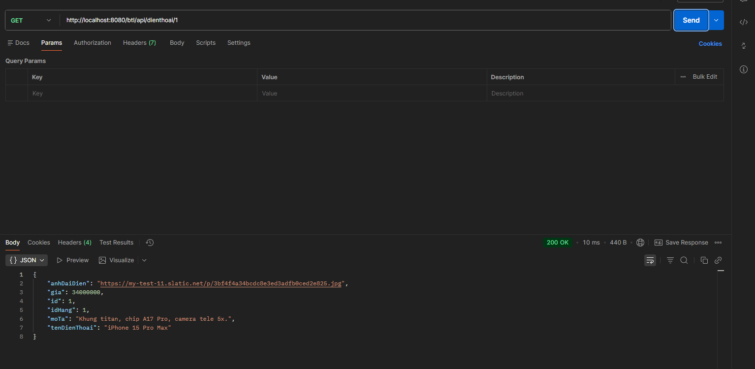

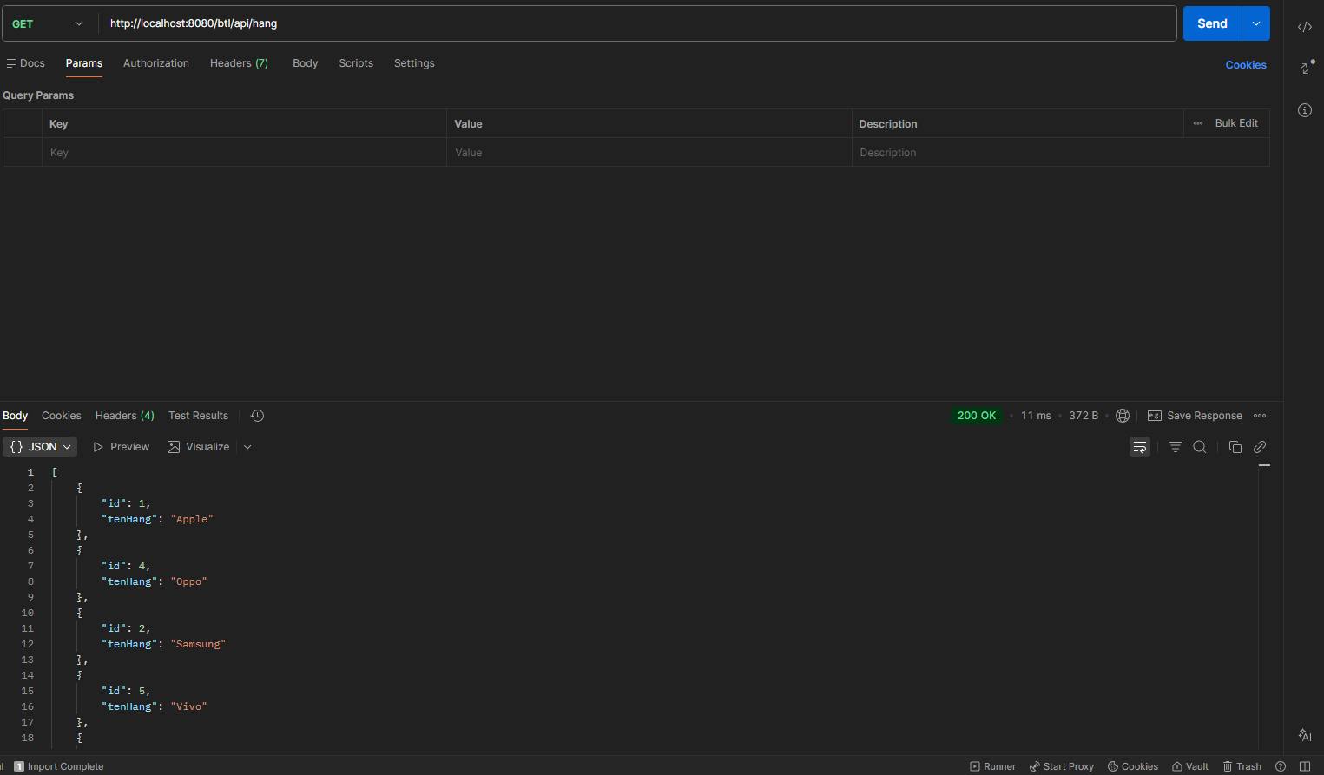

postman request POST 'http://localhost:8080/btl/api/nguoidung/dangky' \
--header 'Content-Type: application/json' \
--body '{
"tenDangNhap": "user_test_1",
"matKhau": "123456",
"hoTen": "Nguyen Van Test",
"soDienThoai": "0912345678"
}'

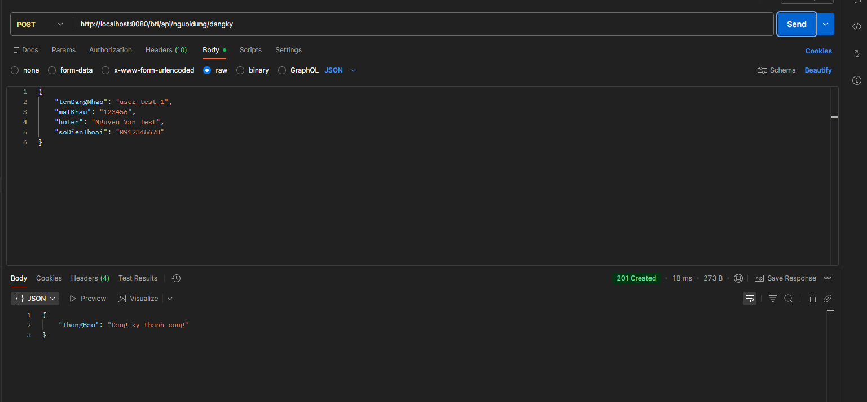

postman request POST 'http://localhost:8080/btl/api/nguoidung/dangnhap' \
--header 'Content-Type: application/json' \
--body '{
"tenDangNhap": "user_test_1",
"matKhau": "123456"
}'
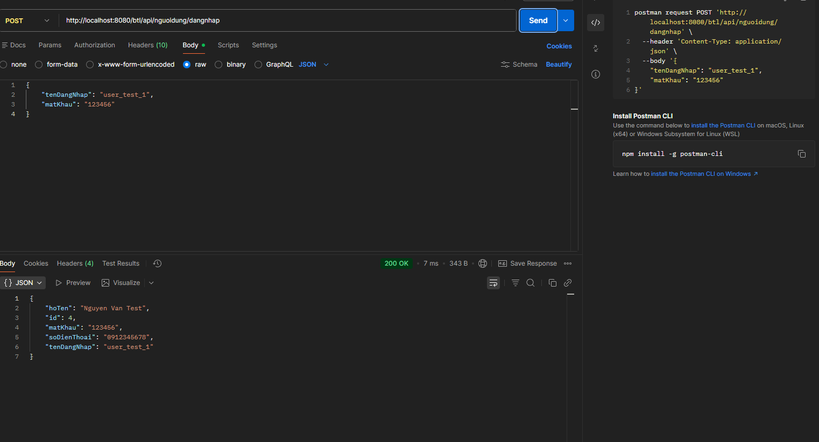

postman request POST 'http://localhost:8080/btl/api/dienthoai' \
--header 'Content-Type: application/json' \
--body '{
"idHang": 1,
"tenDienThoai": "iPhone 15 Pro Max",
"gia": 30000000,
"moTa": "Sieu pham Apple 2023",
"anhDaiDien": "iphone15.jpg"
}'
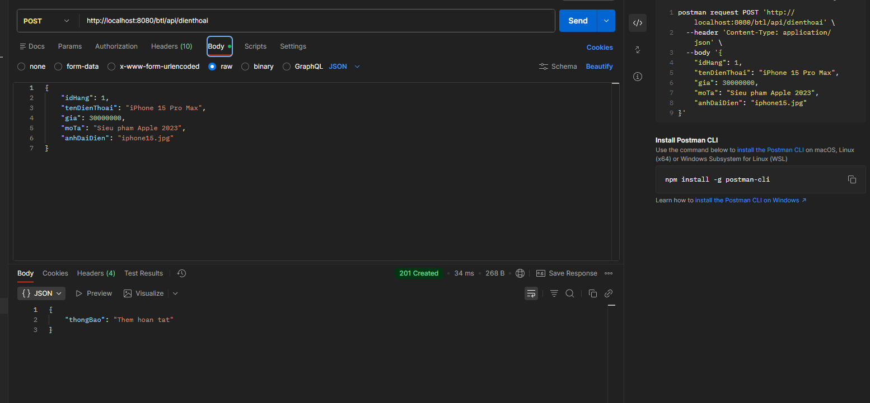

postman request PUT 'http://localhost:8080/btl/api/dienthoai/1' \
--header 'Content-Type: application/json' \
--body '{
"idHang": 1,
"tenDienThoai": "iPhone 15 Pro Max (Gold)",
"gia": 32000000
}'
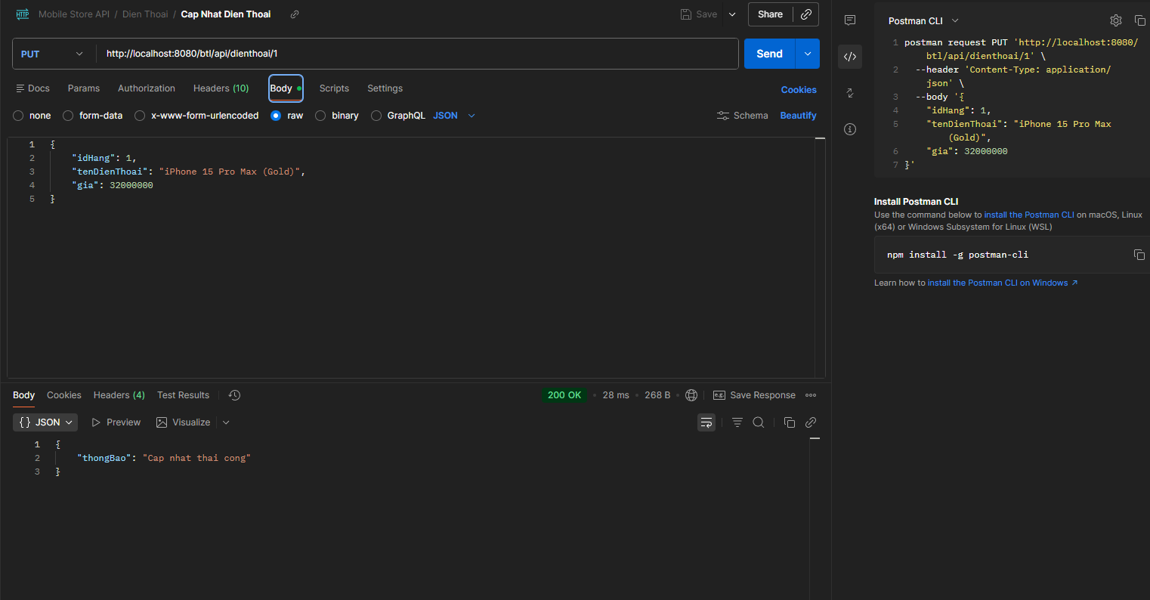

postman request DELETE 'http://localhost:8080/btl/api/dienthoai/2'
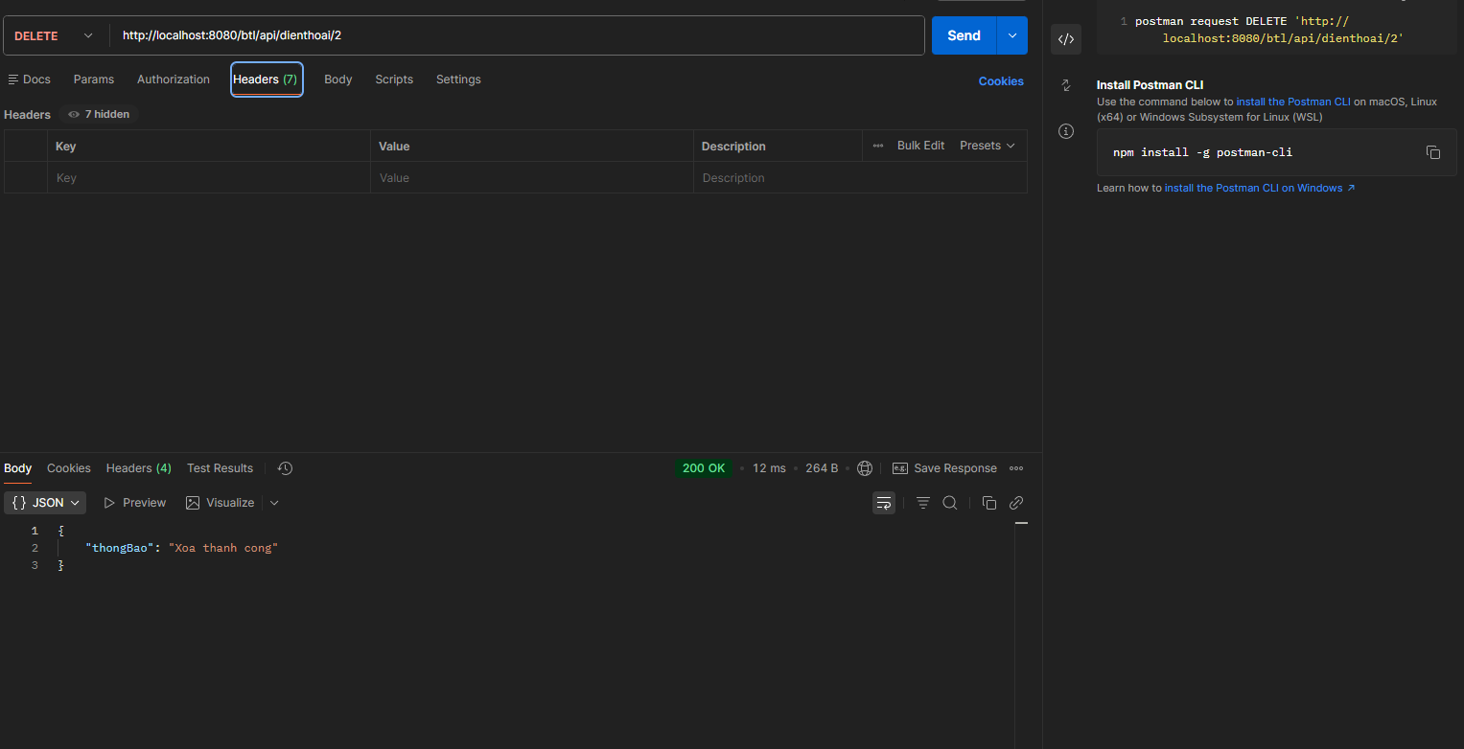

postman request POST 'http://localhost:8080/btl/api/donhang' \
--header 'Content-Type: application/json' \
--body '{
"idNguoiDung": 1,
"idDienThoai": 1,
"tongTien": 30000000,
"trangThai": "Moi dat"
}'

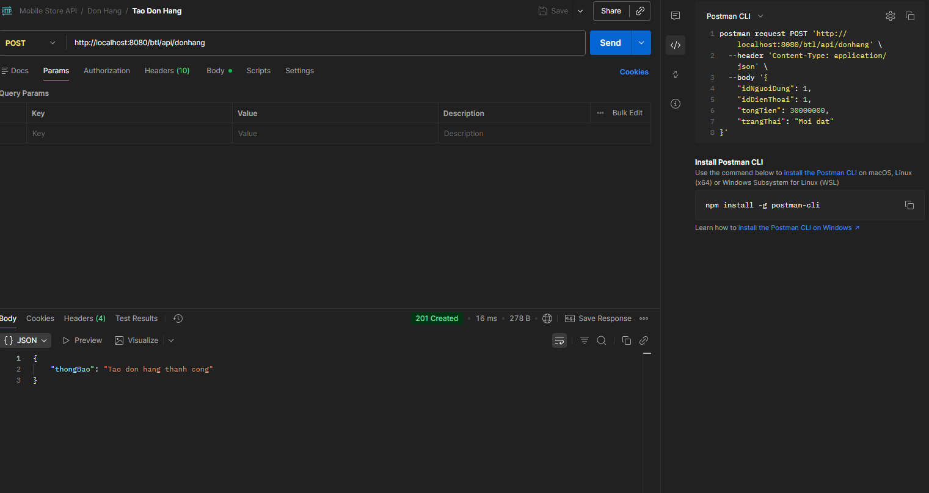

postman request 'http://localhost:8080/btl/api/donhang/1'
